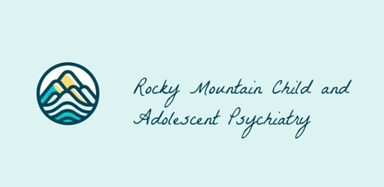

Text Messaging Opt-In & Consent Policy

SMS / Text Messaging Opt-In Policy

Purpose
This policy explains how consumers explicitly consent to receive SMS (text) or MMS messages from Rocky Mountain Child and Adolescent Psychiatry (RMCAP) and how they may decline or withdraw that consent. Consent for text messaging is voluntary, separate from other agreements, and not required to receive care or services.

Scope
This policy applies to all SMS or MMS (text) messages sent by RMCAP using our toll-free messaging number. Messages may include informational, transactional, appointment-related, care coordination, customer service, and administrative messages. RMCAP does not send third-party marketing messages.

Clear Request for SMS Consent
RMCAP explicitly requests your consent to communicate with you via SMS/text messaging. By selecting the consent option below, you acknowledge that you understand you are agreeing to receive text messages, not emails or phone calls.
Consent to receive text messages is separate from acceptance of our Privacy Policy or Terms of Service and is presented as a standalone choice.

Consumer Consent (Explicit Opt-In)
By opting in, you agree to receive SMS/text messages from Rocky Mountain Child and Adolescent Psychiatry (RMCAP) at the mobile phone number you provide.
Messages may be sent using an automated or manual messaging system. Your consent is not a condition of treatment or payment.
If the patient is a minor, the individual providing consent confirms that they are the parent or legal guardian authorized to consent to SMS communication on the patient’s behalf.

Types of Messages You May Receive
By consenting, you may receive text messages related to:
- Appointment reminders and scheduling updates
- Care coordination or follow-up communication
- Practice-related notifications or administrative messages
- Requests for forms or information necessary for care
(RMCAP does not send promotional or third-party marketing text messages.)

Message Details
- Message frequency: Varies based on care and communication needs
- Message & data rates: May apply
- Toll-free messaging number: +1 855-514-6743
- Supported carriers: Most major U.S. carriers

Opt-In / Opt-Out Selection (Required)
Please select one of the following options. Pre-checked boxes are not permitted.
☐ I Agree to Receive SMS/Text Messages from RMCAP
By checking this box, I explicitly consent to receive SMS/text messages from Rocky Mountain Child and Adolescent Psychiatry at the phone number I provided. I understand the types of messages I will receive and that I may withdraw my consent at any time.
☐ I Do Not Agree to Receive SMS/Text Messages from RMCAP
By checking this box, I decline to receive SMS/text messages. I understand that I may still receive services and communications through other methods such as phone calls, email, or patient portals.

How to Withdraw Consent (Opt-Out)
You may withdraw your consent at any time by:
- Replying STOP to any text message, or
- Contacting us at rmcap@rm-cap.com
Once you opt out, you will receive a confirmation message and will no longer receive text messages unless you opt in again.

Help & Support
For assistance, reply HELP to any message or contact us at:
- Email: rmcap@rm-cap.com
- Phone: 801-896-9499

Privacy & Data Use
Your mobile number and SMS preferences will be used solely for communication purposes in accordance with our Privacy Policy. We do not sell, share, or disclose your mobile number to third parties for marketing purposes.
Our full Privacy Policy is available on our website.

Policy Updates
This SMS/Text Messaging Opt-In Policy may be updated periodically. The most current version will always be available on the RMCAP website.

